Comparing Log-distance Ratios with Correlated Errors

**Problem Overview**

We want to check if the log-distance ratios (logdists) obtained from our pipeline match with previous results. The previous results for the comparisons are Springob et al. (2014) and Howlett et al. (2022) for 6dFGS and SDSS peculiar velocities, respectively. Springob et al. 6dFGS PVs differ from ours mainly from the removal of late-type galaxies by visual inspections. Howlett et al. SDSS PVs differ from ours from the brighter limiting magnitude applied to the new sample and the use of 2MASS photometry for the FP observables.

To check the consistencies in the derived log-distance ratios, we take duplicate measurements of the same galaxies and calculate their differences. We can then plot the distribution of those differences and their trend across redshift. The histograms of the logdist differences are as follows:

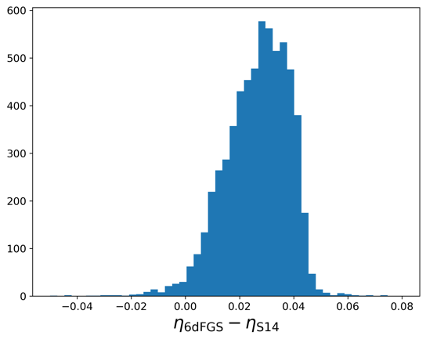

Meanwhile the trend of these differences across redshift are as follows:

To test whether these trends are expected, we performed the same analysis on mock data.

**Experiments with mock data**

We generate one mock sample using the algorithm introduced by Magoulas et al. (2012). This sample have the same redshift limit as our real data, but with a fainter magnitude limit of 14.0. The galaxies are distributed uniformly inside our survey volume and the redshifts are calculated from those uniform distances without making distinction of heliocentric, CMB-frame, or average group redshifts. The input parameters to generate this mock sample are given in the following configuration (JSON):

{

"SMIN_SETTING": "1",

"FP_FIT_METHOD": "0",

"SMIN": "2.00",

"MAG_J_LIMIT": "14.0",

"NFITS": "5",

"NGALS_MOCKS": "10000",

"MEAN_LOGDS": "-3.0",

"STD_LOGDS": "0.5",

"a_INPUT_VALUE": "1.5",

"b_INPUT_VALUE": "-0.85",

"rmean_INPUT_VALUE": "0.20",

"smean_INPUT_VALUE": "2.25",

"imean_INPUT_VALUE": "3.20",

"sigma1_INPUT_VALUE": "0.05",

"sigma2_INPUT_VALUE": "0.30",

"sigma3_INPUT_VALUE": "0.15",

"dI_MAG_SLOPE": "0.06",

"dI_MAG_CONSTANT": "-0.60",

"dI_ERR_CONSTANT": "0.05"

}

The mock sample contains 10000 galaxies. Using the limiting magnitude of 14.0, we fitted the FP and derived the logdists. We iteratively do this process using brighter magnitude limits: 13.5, 13.0, 12.5, and 12.0. To replicate what we did with the SDSS comparison, for a mock galaxy, we calculate the difference between the logdist derived using the brighter magnitude limit and the logdist derived using the faintest magnitude limit,

Where . We then bin in redshift bins and obtain the following plot:

We get similar trend as we obtained in the SDSS comparison. With these various limiting magnitudes, we see that a brighter limiting magnitude yields more offseted logdists (in negative direction), and stronger trend with redshift.

Since the galaxies in our mock sample all have zero peculiar velocities, we can simply check the consistencies by plotting logdists vs redshift (without subtracting with logdist14.0). By binning the logdists measured using the various limiting magnitudes with redshift, we get the following plot:

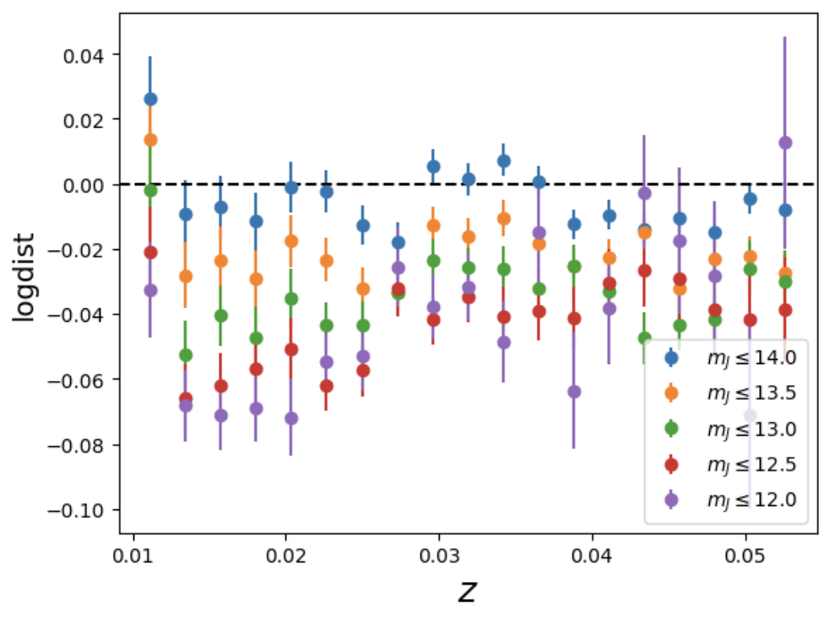

At low redshift, we see that the logdists order from the plot above match with the order from the previous plot (vs ), i.e. the fainter limiting magnitude has more positive logdists. However, as we go to higher redshift, this order is not maintained anymore. Moreover, the difference in the average logdists in each bin between different limiting magnitudes do not yield the vs plot, or